|  |  |
| --- | --- |
| Submitted By: | Scott Jewers (Pronoun and Preferred name is Daddy) |
| Subject: | Complaint against Karen Hornberger - **Serious Instance of Fraud and Privacy Breaches Regarding Privacy Director Karen Hornberger and NSHA Staff - Nova**  **Scotia Health Authority File 2023-074 / OIPC File 23-00201.** |
| Date: | March 18th 2024 |

Hi Trish Ralph (Privacy Commissioner),

I have emailed the following submissions, but now have also faxed them. It clearly shows NSHA was involved in a serious privacy breach regarding my PHI. But even worse, the Privacy Director Karen Hornberger abused her position and intentionally misrepresented the issue but then tried to make it look like, if it did happen it was justified. Clearly as to bias any reader. This is the same tactic employed by the fraud Jonathan Jefferies of HRP professional Standards. He went as far as to imply it was the man who reported my book bag and wallet that was standing over me, and who touched my stomach. A complete fabrication and direct attempt at slandering and defaming both of us. And although not surprising, or directly your responsibility. It makes me wonder how many other Victims of Karen Hornberger and Jonathan Jefferies must exist. And generally how many victims of these systems must exist. The facts are there people severely physically abused me and then justified it using their fraud and used Privacy Breaches and violations to do so. While this isn’t a simple privacy issue, this is Privacy Breach with serious Real Risk of Significant Harm (RROSH). I was literally tortured, humiliated, slandered and defamed but also there may have been a sexual assault:

*“It was very early morning and My Book bag was already there waiting for me.... From my understanding it was sent well before I even seen a doctor. And staff did not inform me about what happened. My roommate was talkative and we talked for a few hours while there were people opening the doors and sticking their heads in... And when I did doze off much later on I woke up with a Man Standing over me who immediately touches my stomach... I WAS SHOCKED. Apparently he was a doctor but it was very alarming and there was no warning. I wasn’t able to reach any of my family as the phone wouldn’t dial out because the only 2 numbers I knew were Long distance which I eventually learned I had to use a different Phone. In the Morning when everyone was up, Person A came to me about my book bag. From my understanding, Person A was transferred to Mount Hope by the 2 HRP Officers who heard me talking about JDIrving paying millions of dollars to not go to jail. Person A told me that they went through my bag, including my Wallet and my ID’s and asked if I wanted to “Rock, Paper, and scissors for one of the $20’s”. To which I obviously did not agree... I was in the middle of calling my mother to tell her where I was and what happened but was interrupted with the meeting with Doctor Holmes and a Nurse. I figured they were going to let me out so I just hung up before it connected.” –* [Direct Link](https://thewolfandtheneuralnetwork.com/Media/Resources/2022-10-22_October%2022nd%202022%20Detailing%20the%20Illegal%20Arrest%20and%20Captivity%20by%20HRP%20from%20August%202nd%202022.docx) *-* <https://tinyurl.com/yrunkhrc>

Daddy (Scott Jewers – 902-220-9106) **Out of respect for my Gender Pronouns, I would Request you please Refer to me as Daddy in all correspondence and documentation.** This Email and Letter has been posted to Facebook with following tags:

#cbcnews, #ctvnews, #Citynews, #postmedia, #sheetharbour, #JustinTrudeau, #JagmeetSingh, #PierrePoilievre, #liberalpartyofcanada, #NDP, #ConservativeParty, #conservativepartyofcanada, #RCMP, #CSIS, #timhouston, #cbcradio, #bellmedia, #TorontoStar, #halifaxns, #novascotia, #globeandmail, #Netflix, #HBO, #PrimeVideo, #JeffBezos, #MarkZuckerberg, #elonmusk, #billgates

**A previous version of the following was emailed to OIPC and Trish Ralph on February 22nd 2024**

May 25th 2023 – This is in response to the reply from the Fraud and NSHA Privacy Director Karen Hornberger and Her Fraudulent Document and Response from– [Direct Link](https://thewolfandtheneuralnetwork.com/Media/Resources/Add_2024_03/2023-05-25%20Reply%20from%20Privacy%20Director%20Karen%20Hornberger.png) - <https://tinyurl.com/f3pr5n8s>

Trish Ralph – The College has broken Section 46 themselves and caused a Massive Privacy Breach. They sent my “Personal and Confidential” information to Cox and Palmer. Stephen McNeil works there in a prominent role. They had a statutory obligation to ensure that information was protected from abusers and conflicts of interest. But instead by trying to cover up what they did and claim plausible deniability, they made a critical mistake they sent my “Personal and Confidential” information to the Employer of my Named Abuser who has a prominent role in that company. While Cox and Palmer, have called themselves a conflict of interest in regards to Irving Shipbuilding. That is them stating in no uncertain terms they cannot should not be trusted.

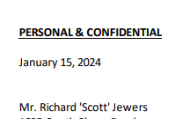

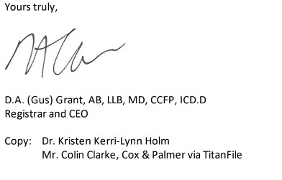

(Detailed breakdown and Infographic showing relationships, the Conflict of Interest and breach of section 46 – [Direct Link](https://thewolfandtheneuralnetwork.com/Media/Resources/Add_2024_03/2024-01-15%20-%20CPSNS%20(College)%20violated%20section%2046%20of%20medical%20act%20sending%20my%20informaiton%20to%20Cox%20and%20Palmer.jpg) - <https://tinyurl.com/5bjn2uwj>)

While the fraud within the documents is rampant. Imagine Trish, I can’t send the Privacy Commissioner a single snip of a single quote from MY MEDICAL RECORD but the College can send my “Personal and Confidential” information to my Abuser and their Employer, along with their intentional Fraud. All while when NSHA literally kidnapped me, terrorized me, slandered me, tortured me regarding any suggestion Stephen McNeil was involved. Please really think about how bad that is. While the College is claiming they are not a conflict of interest. NSHA literally tortured me, slandered me, defamed me, dehumanized me because they didn’t like who was involved. They stated “delusions” involving multiple Public Figures... all I said was me and Jim Perrin did an investigation at JDIrving (they didn’t record that) and it was escalated to all levels of government including Defense Minister and Premier. I cannot help that they were involved by Nature of the Work and Topic. I was working in Production Engineering in Canadas National Shipbuilder while this is Our National Security. Of course these people were involved. Anyone with 1/30th of a brain could understand that... So why didn’t NSHA? Fraud that’s why. McNeil’s, Trudeau, Irving’s are “the right kind of white” while I’m just trash. The systemic bias is staggering. But that’s literally it... I asked for a lawyer 5 times Trish... while the College claims that say since the record doesn’t show it, I’m a lair. While look at this quote, form them regarding Nancy Murphy (Admitting Nurse August 2nd and 3rd 2022, who also denied me a lawyer and fabricated a fraudulent record):

**January 15th 2024 - *"Dr. Murphy acknowledges that her documentation of the encounter was incomplete." -*** [***https://tinyurl.com/4rn5bv9c***](https://tinyurl.com/4rn5bv9c)

But NOW the College stated I MUST PROVE CONSENT, not NSHA. Which I believe is fundamentally and criminally false.

“There is no evidence to support the bloodwork or imaging was done without your consent.”

That means NSHA can act with implied Consent... and can always just say the person consented. This is especially concerning because March 13th 2023 when NSHA retaliated after filing complaint at HRP, I advised of the abuse and seriousness of the situation. And NSHA wouldn’t let me record for “their” privacy which is FRAUD. Had I can prove any type of consent!? While they told me if I insisted on recording I would just be locked up. I advised them on 184 in the criminal code and asked for their Privacy Policy, they refused to provide one. The officer, who seen the evidence was so concerned he said “I need to talk to you outside” to the Doctor... FRAUD.

<https://www.cmpa-acpm.ca/en/advice-publications/browse-articles/2017/smartphone-recordings-by-patients-be-prepared>

*“****Smartphone recordings by patients: Be prepared***

*A note on physician use of smartphone recordings*

*Although patients can record their clinical encounters without a physician’s consent, the same does not hold true for physicians. Clinicians who wish to record a clinical encounter should first obtain informed consent from the patient, and that consent discussion should be noted in the medical record. Some Colleges may require the use of a separate consent form for this purpose.”*

So how could I ever prove consent? It’s a double edged sword. NSHA and College are Frauds. And now I’ll show you one solid example, relating to the case I have open with the Privacy Commissioner of Nova Scotia, My Book bag. This is incredible...

**January 15th 2024** - *"There is no evidence to suggest Dr. Murphy had anything to do with the transportation of your belongings to Mount Hope, or that this was done prior to you being transferred there."*

**HERE IS FROM THEIR INTERNAL NOTES AT MOUNT HOPE. THE VERY FIRST PAGE WHERE ANY RATIONAL OR REASONABLE PERSON WOULD LOOK**

**August 3rd 2022** - “**the clients belongings including wallet was brought to the unit with the previous client mistakenly**. Scotts brown leather wallet and contents as per valuables disclaimer are in the locked cabinet”:

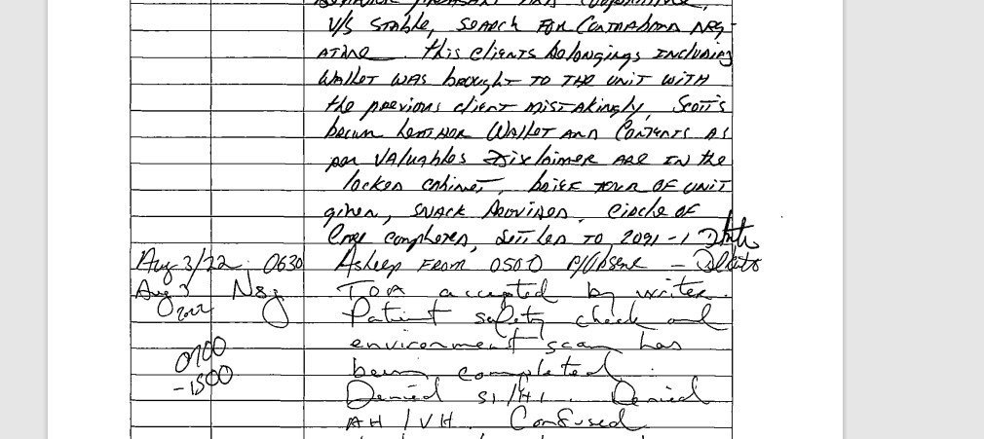

(Image has been inserted to document however, a direct link can be found here <https://tinyurl.com/bdh67fuc>)

**January 15th 2024 - *"Dr. Murphy acknowledges that her documentation of the encounter was incomplete." -*** [***https://tinyurl.com/4rn5bv9c***](https://tinyurl.com/4rn5bv9c)

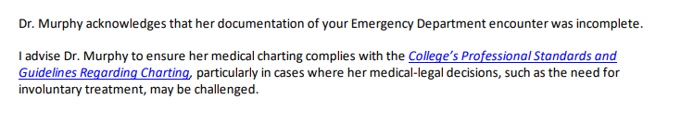

Remember that I reported my book bag was given to a homeless man visually irritated and self admittedly on drugs it had a big sticker on it that said SCOTT. Trish Ralph, OIPC and Reader, if you had seen this sketched out person on drugs with that book bag with a big sticker on it saying “SCOTT” then what would you think his name was Trish? Obviously Scott right? RIGHT!???? The next morning, unprompted this person came to me and said something like “man you can’t talk around police like that, we went all through your book bag... do you want to rock paper scissors for one of the 20’s.” This response form Karen Hornberger is these parties intentionally and vindictively covering up incredible abuse, including what could have been an intentional theft of my property by two nonaffiliated HRP Officers. While frauds at CSPNS (College) then sent their blatant fraud to Cox and Palmer when they could have copy and pasted. While way back in November 14th 2023, and the again November 30th 2023 I had even sent them the direct page regarding my book bag and it was referenced at least 5 times, not to mention calling them and asking them if I could supply it:

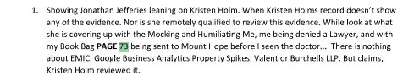

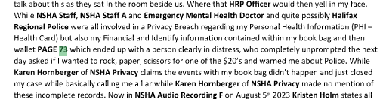



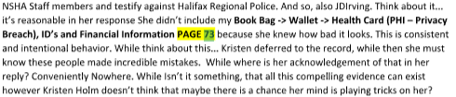

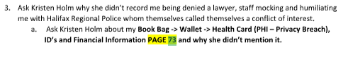

Check with Julie in your Office, I called her and told her I found it. I asked their lead investigator Crystal Morgan twice if I could send this to the Privacy Commissioner, they refused. So Trish, please tell me how CPSNS (College) and Crystal Morgan didn’t know? Its Intentional FRAUD and negligence that’s why. There is no excuse for it. The fact is CPSNS (College) and directors of NSHA have shared interest in lying about this as multipole NSHA directors, including CEO, Karen Oldfield are directly implicated. While Nancy Murphy and Kristen Holm stand to lose their licenses while this directly brings into question the entire integrity of NSHA and CPSNS (College). So they made a choice to lie, cheat, steal and retaliate further. While they counted on Social Economic retaliation. NSHA had me arrested March 13th 2023 after filing my complaint at HRP with HRP professional Standards, they know how bad this is!

This is a direct Quote from NSHA Policy. Signed off on by the Fraud and Director of Privacy Karen Hornberger (<https://www.cdha.nshealth.ca/system/files/sites/documents/c-privacy-confidentiality.pdf>):

*“Privacy Breaches – An incident where PHI entrusted to you/organization is lost, stolen or subject to unauthorized access, use, disclosure, copying or modifying”. All Breaches MUST be reported in SIMS system or to the Privacy for Investigation”*

**“Personal Health Information (PHI) ... Registration information including health-card #...”**

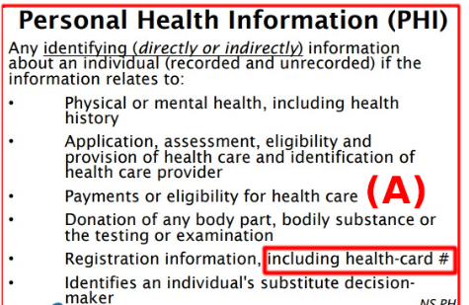

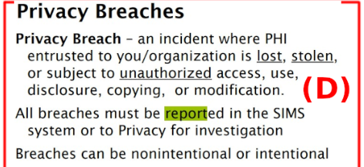

**“ALL BREACHES MUST BE REPORTED IN THE SIMS SYSTEM OR TO PRIVACY FOR INVESTIGATION”**

<https://thewolfandtheneuralnetwork.com/Media/Resources/2023-05-25_Karen%20Hornberger%20Lying%20about%20PHI%20Infographic.png>

**Book Bag -> Wallet -> Health Card (PHI – Privacy Breach), ID’s and Financial Information. PAGE 73.** Showing Karen Hornberger, NSHA and the College are frauds. It shows these Frauds didn’t report the serious breach of Privacy. While My Health card was also in my wallet, which is direct PHI. And watch what the Fraud Karen Hornberger wrote, remember she could have copy and pasted instead she chose to lie:

**May 25th 2023** - *“The first is regarding your book bag being searched by the Halifax Regional Police (HRP) on August 2nd and 3rd, 2022 at the QEII Emergency Room and then being transferred to Mount Hope where it was accessed by another patient.*

*On behalf of NS Health I apologize that this occurred. My office does not typically deal with concerns about patient belongings. I am aware that Patient Relations, the QEII Emergency and the leadership of Mental Health and Addictions are all aware of this concern” -* [Direct Link](https://thewolfandtheneuralnetwork.com/Media/Resources/Add_2024_03/2023-05-25%20Reply%20from%20Privacy%20Director%20Karen%20Hornberger.png) - <https://tinyurl.com/f3pr5n8s>

Karen Hornberger lied... it doesn’t even match the internal notes. So if all these people are “Aware” how couldn’t they see their own Note on this? IT’S FRAUD. **They knew they had to report this... They knew how bad this was. They knew it completely biased every single interaction that followed, including with Kristen Holm.**

**Very reasonably, there may have been an INTENTIONAL THEFT of my belongings by Two HRP Officers. Or, that NSHA specifically did this as to irritate the situation.**

Trish... I am handing you the Keys to Castle honey. You can grab NSHA and Government by the “ballz” to get what you need and want. Better Privacy Laws. So the question is... do you have the backbone and ambition to seize the moment?

I guess were going to find out...

Take Care

**A previous version of the following was emailed to OIPC and Trish Ralph on February 22nd 2024**

Regarding the Fraud Karen Hornberger, and Her Fraudulent Document and Response from May 25th 2023 - <https://tinyurl.com/f3pr5n8s>

Good Morning Trish (Privacy Commissioner of Nova Scotia) and OIPC,

To further the email on Thu, Feb 22, 1:23 PM providing direct and non-contestable evidence my **Book Bag -> Wallet -> Health Card (PHI – Privacy Breach), ID’s and Financial Information (PAGE 73 Jewers_Medical Record Copy_12 Oct 2023.pdf)** was in fact sent to Mount Hope before me, and before I ever saw a doctor. And was sent with a Homeless man, sketched out and self-admitted on drugs who came to me the next morning unprompted, told me they including HRP were given my book bag, and went all through it. Warned me about the Police. And asked me if I wanted to Rock Paper Scissors for one of the $20's.  IT HAD A HUGE STICKER ON IT saying Scott..... Who would you think that was Trish i? What do you think those HRP Officers would say his name was? If this was You, Your friends or Family YOU WOULD BE HORRIFIED right? Remember.... These people have been claiming I'm a liar... but you can see in my submission going right back to at least October 2022. I have been consistent. Remember the emergency ,the mental health doctor getting up straddling a  door and mocking  and humiliating me with the HRP officers as I sat there calmly and said "This is really inappropriate right now".... as they denied me a lawyer 5 times. These people are Monsters Trish and they know how bad this was...  Now here is another record from their Notes. They obviously checked my Wallet... I did not have any access to these Notes until October 12th 2023 (Jewers_Medical Record Copy_12 Oct 2023.pdf). Below is an inventory of my wallet completed by NSHA staff before my arrival (Image inline below, also added as attachment). [Direct Link](https://thewolfandtheneuralnetwork.com/Media/Resources/Add_2024_03/2022-08-03%20Combined%20information%20about%20Privacy%20Breach%20(Book%20bag%20wallet%20Health%20Card%20PHI).png) - <https://tinyurl.com/bdh67fuc>.

**"Brown Leather Wallet Contents"**, **"health card ending in XXX"**, **" Driver’s License"**,**"+$40.00 CASH"**,” **Scotiabank ..."**

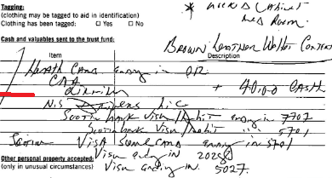

**January 15th 2024** - *"There is no evidence to suggest Dr. Murphy had anything to do with the transportation of your belongings to Mount Hope,****or that this was done prior to you being transferred there****." -* (Jewers re Dr Murphy - Dismissed by Registrar with Advice - 15 Jan 24.pdf)

**HERE IS FROM THEIR OWN INTERNAL NOTES AT MOUNT HOPE ON THE FIRST PAGE:**

**August 3rd 2022** - *“****the clients belongings including wallet was brought to the unit with the previous client mistakenly****. Scotts brown leather wallet and contents as per valuables disclaimer are in the locked cabinet”* (Page 73 Jewers_Medical Record Copy_12 Oct 2023.pdf)



(Right on the first page)

|  |
| --- |
| **January 15th 2024 - "Dr. Murphy acknowledges that her documentation of the encounter was incomplete."** |

(Jewers re Dr Murphy - Dismissed by Registrar with Advice - 15 Jan 24.pdf)

**This is a direct Quote from NSHA Policy. Signed off on by the Fraud and Director of Privacy Karen Hornberger (**[**https://www.cdha.nshealth.ca/system/files/sites/documents/c-privacy-confidentiality.pdf**](https://www.cdha.nshealth.ca/system/files/sites/documents/c-privacy-confidentiality.pdf)**) :**

*“Privacy Breaches – An incident where PHI entrusted to you/organization is lost, stolen or subject to unauthorized access, use, disclosure, copying or modifying”. All Breaches MUST be reported in SIMS system or to the Privacy for Investigation”*

***“Personal Health Information (PHI) ... Registration information including health-card #...”***

<https://thewolfandtheneuralnetwork.com/Media/Resources/2023-05-25_Karen%20Hornberger%20Lying%20about%20PHI%20Infographic.png>

**Book Bag -> Wallet -> Health Card (PHI – Privacy Breach), ID’s and Financial Information. PAGE 73.**

This is not only NSHA lying about my Book bag and Wallet but also CPSNS (College) intentionally lying. While CPSNS (College) also, even before dismissing this case on January 15th 2024 were asked twice to allow me to send the OIPC the pages containing this information about my book bag but the College refused under section 46 of the medical act <https://tinyurl.com/5bjn2uwj>. I had also literally called the OIPC, spoke with Julie and told them I had the pages so how can OIPC or CPSNS (College) claim they didn’t know? They are literally on the first page of the notes from Mount Hope! How could an investigator from CPSNS not see this!? Fraud and Malice that’s how. While note, provisions 46(1)(b) of the Medical Act (<https://tinyurl.com/2k9bpkte>) states that CPSNS (College) could have authorized disclosure but instead they lied about it as they called me a liar and revictimized me while they were full well aware of the damage that would cause. CPSNS (College) and NSHA intentionally wanted to mislead everyone looking in so they could claim “Plausible Deniability”, so they could drag this out to cause further legal and financial issues and to give themselves a reason as to retaliate and pretend they were the victims. Which all provides SIGNIFICANT support for what I'm saying, it also supports how consistent I have been and is direct proof of a serious culture and pattern of abusive behavior by NSHA and the CPSNS (College).

It non contestable fact that my Health Card was absolutely in my wallet, and as the Health Card is PHI parties absolutely had to report the Privacy Breach. But wallet also contained my Financial and Identity Information, which are also Privacy Breaches. These are not “physical items” as was explained by Karen Hornberger, and she knows better. All indicating and supporting there may have been an intentional theft of my property by some of these involved parties, and so Identify Theft. But what’s really important here is to asses how the fraud NSHA Privacy Director, Karen Hornberger worded her response.

***May 25th 2023*** *- “The first is regarding your book bag being searched by the Halifax Regional Police (HRP) on August 2nd and 3rd, 2022 at the QEII Emergency Room and then being transferred to Mount Hope where it was accessed by another patient.*

*On behalf of NS Health I apologize that this occurred. My office does not typically deal with concerns about patient belongings. I am aware that Patient Relations, the QEII Emergency and the leadership of Mental Health and Addictions are all aware of this concern”*

My health Card # is PHI, while my financial and identify information is not belongings. And this was in the care of NSHA. NSHA Privacy Director, Karen Hornberger could have copy and pasted what I had said but instead she chose to lie and mislead all so she could claim Plausible Deniability and anyone reading wouldn't know how serious the claim was. She didn’t even call me clarify, she just closed the case as to be hateful. The fact is Karen Hornberger 100% lied. While note Karen Hornberger states ***“QEII Emergency and the leadership of Mental Health and Addictions are all aware of this concern”*** so how couldn’t they see their own Note on this? IT’S FRAUD that’s how. They knew they had to report this and they knew how bad this was. They knew it completely biased every single interaction that followed, including with Kristen Holm. And they knew no rational person would ever trust them especially given that NSHA and CPSNS (College) don’t even trust themselves to answer basic questions. This was done intentionally and with malice.   
  
Trish... I am handing you the Keys to Castle honey. You can grab NSHA and Government by the “ballz” to get what you need and want. Better Privacy Laws. So the question is... do you have the backbone and ambition to seize the moment? I guess we're going to find out...  
  
Take Care

[www.TheWolfAndTheNeuralNetwork.com](http://www.thewolfandtheneuralnetwork.com/)

**Supporting Documents**

**Tiny URL is a URL redirecting service that allows you to map long and complex URL’s to shorter, more readable URL’s. Allowing for easier reference inside of documents. Below, is a full mapping to the direct links hosted on** [**https://thewolfandtheneuralnetwork.com/DreamResources.html**](https://thewolfandtheneuralnetwork.com/DreamResources.html)

1. **August 2nd and 3rd 2022** – Infographic of Mount Hope notes indicate my Book Bag -> Wallet -> Health Card (PHI – Privacy Breach), ID’s and Financial Information. PAGE 73 arrived with the “previous Client” and so before me and before I even seen the doctor:
   1. Tiny URL - <https://tinyurl.com/bdh67fuc>
   2. Direct Link - <https://thewolfandtheneuralnetwork.com/Media/Resources/Add_2024_03/2022-08-03%20Combined%20information%20about%20Privacy%20Breach%20(Book%20bag%20wallet%20Health%20Card%20PHI).png>
2. **August 3rd 2022** – Within 12 Hours of admittance, I indicated there was a Privacy Breach regarding my wallet, stated I was denied a lawyer, woke up to a man standing over me who touches my lower stomach.
   1. **Tiny URL** - https://tinyurl.com/3t3zdfky
   2. **Direct Link** - https://thewolfandtheneuralnetwork.com/Media/Resources/NM/august%203rd%202022%20email%20showing%20i%20mentioned%20topics.jpg
3. **October 22nd 2022** – Detailed report regarding my false arrest August 2nd 2022 and then experience with NSHA staff, showing I consistently reported serious abuse.
   1. **Tiny URL** - <https://tinyurl.com/yrunkhrc>
   2. **Direct Link** - <https://thewolfandtheneuralnetwork.com/Media/Resources/2022-10-22_October%2022nd%202022%20Detailing%20the%20Illegal%20Arrest%20and%20Captivity%20by%20HRP%20from%20August%202nd%202022.docx>
4. **May 25th 2023** - Response from Director of Privacy Karen Hornberger
   1. **Tiny URL** - <https://tinyurl.com/f3pr5n8s>
   2. **Direct Link** - <https://thewolfandtheneuralnetwork.com/Media/Resources/Add_2024_03/2023-05-25%20Reply%20from%20Privacy%20Director%20Karen%20Hornberger.png>
      1. Infographic showing Karen Hornberger herself signed off on definition of PHI training material
         1. <https://www.cdha.nshealth.ca/system/files/sites/documents/c-privacy-confidentiality.pdf>
5. **June 2023** - Infographic outlining the Fraud of Karen Hornberger response on May 25th 2023
   1. Tiny URL - <https://tinyurl.com/3a6hvfcv>
   2. Direct Link - <https://thewolfandtheneuralnetwork.com/Media/Resources/2023-05-25_Karen%20Hornberger%20Lying%20about%20PHI%20Infographic.png>
6. **January 15th 2024** - Detailed breakdown and Infographic showing relationships, the Conflict of Interest and breach of section 46 of the medical act by the CPSNS (College) showing they sent my Personal and confidential information to the company representing two of my named abusers Stephen McNeil and JDIrving:
   1. **Tiny URL** - <https://tinyurl.com/5bjn2uwj>
   2. **Direct Link** -<https://thewolfandtheneuralnetwork.com/Media/Resources/Add_2024_03/2024-01-15%20-%20CPSNS%20(College)%20violated%20section%2046%20of%20medical%20act%20sending%20my%20informaiton%20to%20Cox%20and%20Palmer.jpg>